ELISTAT
Îmbogățirea vieții persoanelor vârstnice prin intermediul art-terapiei
2020-1-TR01-KA227-ADU-097696

Resurse Și Referințe Utile
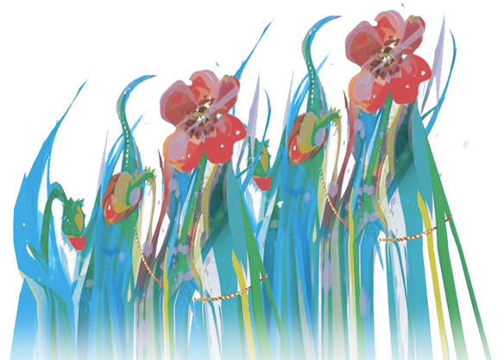
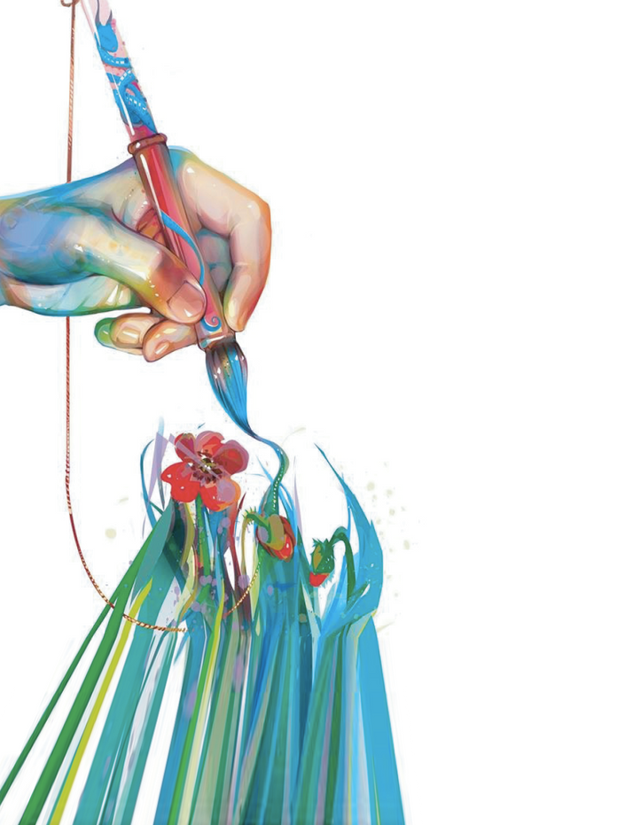
Pentru Antrenori

Bárbara, Luís (2009). Métodos e Técnicas Pedagógicas/Andragógicas. Edição FCA – Teto de Nuvens
Case, Caroline, Tessa Dalley , "The art therapy room" (2014) in The Handbook of Art Therapy ed. Caroline Case and Tessa Dalley. accessed 01 july. 2022 , Routledge Handbooks Online: https://www.routledgehandbooks.com/doi/10.4324/9781315779799.ch3
Carr, Catherine & Feldtkeller, Barbara & Havsteen-Franklin, Dominik & Huet, Val & Karkou Vicky & Sandford Stephen (2018) Group Arts Therapies Manual. East London Foundation NHS Trust Queen Mary University of London. Accessed on 01 July 2022. https://www.elft.nhs.uk/sites/default/files/5.%20190131ERAManualv1-1.pdf
Ceitil, Mário (2010). Tendências de evolução da Formação Profissional. Revista Formar. Nº 71. pp. 41-42
Coricciati, Anna Rita, Stinziani, Sabrina, Le immagini raccontano, 2011
Danieli, Yafit & Snir, Sharon & Regev, Dafna & Adoni-Kroyanker, Michal. (2019). Suitability of the art therapy room and changes in outcome measures in the education system. International Journal of Art Therapy. 24. 1-8. 10.1080/17454832.2018.1564778. accessed 01 july 2022. https://www.researchgate.net/publication/330226776_Suitability_of_the_art_therapy_room_and_changes_in_outcome_measures_in_the_education_system
Ferreira, Paulo da Trindade (2007). Guia do Animador na Formação de Adultos. Coleção Pontos de Referência. Editorial Presença
Gouveia, João (2005). Manual de Avaliação da Formação. POEFDS, Centro de Recursos em Conhecimento.
Hargie, Owen (2011). Skilled interpersonal communication: research, theory and practice. 5th edition. London and New York: Routledge
Harper, Sarah, Hamblin, Kate, “This is living”, Oxford Institute of Ageing, University of Oxford
Lieban, Marian (2004). Art therapy for groups. A handbook of themes and exercises. Second edition. Brunner Routledge. Accessed on 01 July 2022. https://readpbn.com/pdf/Art-Therapy-for-Groups-Sample-Pages.pdf
Lopes, L. E Pereira, M. (2004). Métodos e Técnicas Pedagógicas. Lisboa: Fundação para a Divulgação das Tecnologias da Informação
National Endowment for the Arts, The arts and aging, building the science, National endowment for the Arts Office of research & Analysis, 2013
Nuove Arti terapie, N. 18/2011
Pacheco, José Augusto (2011). Discursos e lugares das competências em contextos de educação e formação. Coleção Panorama. Porto Editora
Zubala, Ania & Kennel, Nicola & Kackett, Simon (2021). Art Therapy in the Digital World: An Integrative Review of Current Practice and Future Directions. In Frontiers of Psychology.Accessed on 01 July 2022. https://doi.org/10.3389/fpsyg.2021.600070
https://www.casadeglietruschi.it/news/arteterapia-e-anziani-larte-del-benessere/
https://www.researchgate.net/publication/283901327_Dance_and_Aging_A_Critical_Review_of_Findings_in_Neuroscience
https://www.frontiersin.org/articles/10.3389/fpsyg.2021.635975/full
https://ebcj.mums.ac.ir/article_11286.html
https://journals.sagepub.com/doi/10.1177/0891988720901789
https://nexus.jefferson.edu/health/how-can-we-harness-new-applications-of-art-therapy/

